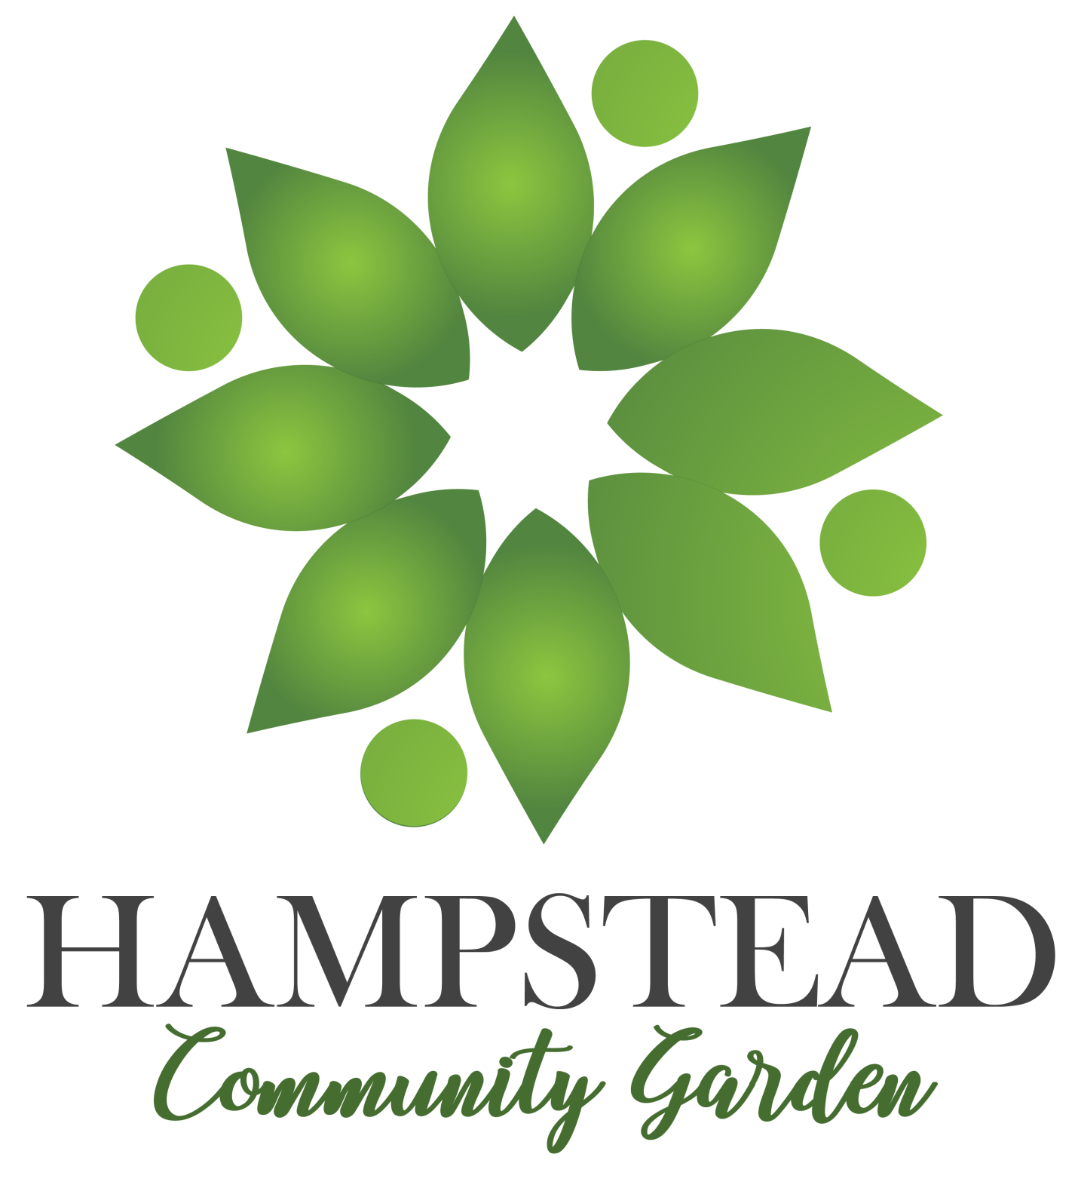

Table of Contents
- Community Garden Definition and Benefits
- HCG
  - Mission and Purpose
  - Location and Benefactor
- Board of Directors
  - Volunteers
- Greenhouse Division
- Programs
  - Proud Produce
  - Friendly Flowers
  - Educational Enrichment
    - Junior gardeners
    - Adult Education
    - Native Plants
    - Earth Day Hampstead
  - Community Composting
- Local Plots and Lottery
- Community Contributions
- Marketing
- Financial information

Community Garden Definition and Benefits
A community garden is a single piece of land collectively gardened by a group of people. Community gardens utilize either individual or shared plots on private or public land while producing fruit, vegetables, and/or plants grown for their attractive appearance. Around the world, community gardens can fulfill a variety of purposes, including aesthetic and community improvement, promoting physical and mental well-being, and land conservation. For the most accurate and helpful information, please review the following resource:
https://www.communitygarden.org/
Benefits of Community Gardens
- Improves the quality of life for people in the garden
- Provides a catalyst for neighborhood and community development
- Stimulates social interaction
- Encourages self-reliance
- Beautifies neighborhoods
- Produces nutritious food
- Reduces family food budgets
- Conserves resources
- Creates opportunity for recreation, exercise, therapy, and education

The Hampstead Community Garden
The Hampstead Community Garden (the HCG) is a multi-functional community garden and space dedicated to managing several programs that benefit the environment and lessen the environmental footprint of the Town of Hampstead. It is the goal and mission of the HCG to provide a regulated and organized communal space where community members and leaders can grow plants and vegetables; it is designed to ultimately feed and educate the Town at all levels.
Location
The HCG is located at 1400 Panther Drive on the grounds of the former North Carroll High School. The greenhouse rear faces Panther Drive and has convenient parking across the street with cross walks. The greenhouse property and land for the HCG has been generously donated to the Town of Hampstead through Jennifer Lleras, of Hampstead Marketing and Design, by Athan Sunderland, CEO at Capital Sports Group.
As primary benefactor of the HCG, Athan Sunderland and Capital Sports reserves the right to first sponsorship space, when available, and primary benefits¹ of the HCG. HCG also has right of first refusal on any and all pending sponsorships and major decisions involved with the HCG. Capital Sports will also have a voting position on the Board of Directors (BOD) and will be included in all voting decisions.
Board of Directors and Major Volunteer Positions
The BOD shall consist of nine (9) available positions and shall follow Robert’s Rules of Order when assembling as a committee and for decision-making purposes.
Director Positions:
- President
- Vice President
- Treasurer
- Secretary
- Volunteer Director
- Assistant Volunteer Director
- Fundraising Director
- Program Director
- Assistant Program Director
As acting President of the HCG, the first BOD shall be chosen by Jennifer Lleras. Upon the appointment of at least four (4) core members, a vote for additional BOD seats shall be permissible if necessary.
For specifics on how the BOD will operate, please review: https://robertsrules.com/

Volunteers
The HCG will rely solely on the hard work of community volunteers. Volunteers must register on the HCG website and are subject to a background check by the State of Maryland. Volunteers may come from neighboring towns, but priority shall be given to those in the 21074 zip code. The HCG accepts volunteers of all ages; it offers youth ages 12-18 community services hours and encourages those aged 0-11 to participate in our Junior Gardener program. All volunteers and their guardians, if applicable, shall sign a volunteer waiver which protects the HCG against injury and theft and shields the organization from prosecution. Volunteers shall participate at their own risk. The HCG will acquire volunteers through social media marketing campaigns and by partnering with local agricultural programs and communities. Additionally, the HCG will collaborate with Manchester Valley High School to be a provider of student service learning hours.

Volunteers may participate in several capacities:
Vetted Volunteers
Volunteers who have agreed to participate regularly in the green house program(s); these volunteers shall have assigned roles and project to which they dedicate their time.

Regular Volunteers
Volunteers who have agreed to participate regularly and will perform routine maintenance and jobs (as listed on the volunteer board).
Floating Volunteers
Volunteers who cannot commit to participate regularly, but register so they may volunteer at their convenience.

Sponsors and Corporate Benefactors
The HCG is currently applying for 501(c)(3) status. Upon the establishment of the 501(c)(3) status, the HCG shall accept tax-deductible donations as well as sponsors and corporate benefactors via the HCG website.
The HCG is determining ways to showcase corporate benefactor information in the future.

Greenhouse Division
The greenhouse and respective outdoor property shall be divided into the following sections (subject to change):
- 40-50% of the greenhouse will be dedicated solely to production of produce to benefit the low income members within the 21074 zip code.
- 20% of the greenhouse will be dedicated to growing florals which shall be donated to local elementary schools for use in flower sales, allowing the schools to fundraise and receive 100% profit to benefit their PTA.
- 15% of the greenhouse shall be dedicated to Educational Enrichment Programs and learning.
- 15% of the greenhouse shall be sectioned into plots and offered through a lottery each year. These plots will be subdivided between community members and restaurants.
- Outdoor space will be dedicated to produce that is too large to grow indoors (mainly corn), the Native Plants Initiative, and Earth Day saplings.
- Outdoor Space will be dedicated to Community Composting.
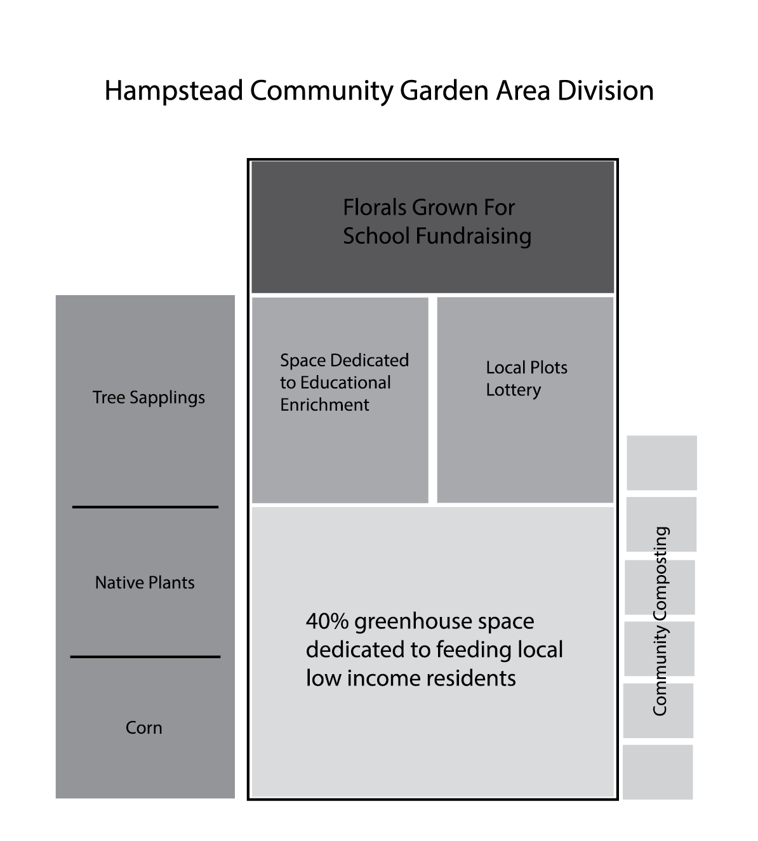
Programs
One of the primary objectives of the HCG is to offer year-round programs that benefits and enrich the community through education and plant production. While programs are subject to change, the legacy programs are to include:
Proud Produce Program
The Proud Produce Program is the primary function of the greenhouse and provides produce to low income community members during the growing season.
Who is Involved?
The Program is run solely by volunteers. Each volunteer (vetted and regular) may be assigned to a plot and will be responsible for production of solely this assigned plot. They will need to arrange for germination, scheduling, planting, growing, watering, and maintaining this plot and its yield.
The distribution of fresh grown produce through the Proud Produce Program will begin as a weekly dispersion of individual selections of produce harvested by volunteers. The dispersion will be announced on the website and social media and will be given out on a first-come, first-served basis. The program’s rules and regulations are subject to change based on experience and opinion of the BOD; this allows the program the flexibility to support change for its benefit and the benefit of its recipients.
What is given out?
The indoor and outdoor space dedicated to the Proud Produce Program will produce vegetables that are the easiest to grow, the least susceptible to disease, and result in the largest yield; this shall provide the recipients the most nutritious and versatile items. These crops include, but are not limited to, the following:
- Corn
- Tomatoes
- Potatoes
- Green Peppers
- Beans
- Onions
- Zucchini
- Squash
- Melons
- Leafy Greens
- Carrots
- Eggplant
- Information cards about each item and suggested recipes
Where is produce given out?
The HCG intends to host a typical food pantry style event in the form of a drive-through when produce is available. When additional produce is available, there may be an option to have a community stand that is located in the greenhouse’s private parking lot.
When is produce given out?
Because produce grows at different rates and yield is undetermined, the exact timing of produce availability will be completely dependent on the volunteers and the harvest times. As produce begins to grow and yield, a harvest schedule forecast can be made and adjusted; this will allow volunteers to plan out events two weeks in advance and advertise the events to the community in need. It is assumed that the greenhouse busy season will be March-October.

Friendly Flowers Program
The Friendly Flowers Program is designed to grow inexpensive and easy to maintain florals for the sole purpose of providing local elementary school PTAs with flowers to sell in May in conjunction with Mother’s Day. By growing these florals, the HCG will be providing the PTA with a fundraiser that gives back 100% of the proceeds to the school.
Who is Involved?
The Program is run solely by volunteers. Each volunteer may be assigned to manage several roles in growing flowers for the program, including germinating, planting, watering, weeding, and trimming.
The recipients of the flowers are local elementary schools; the first eligible elementary school shall be Spring Garden Elementary School. The following year the BOD shall decide the method of school selection shall be utilized in the future.

What is given out?
Each year, the indoor space dedicated to this program shall produce any of the following easy and inexpensively grown flowers, unless otherwise chosen by the BOD or donated by an outside party.
- Marigolds
- Petunias
- Dianthus
- Impatiens
Where are flowers given out?
Flowers will be picked up by the participating PTA and sold or dispersed at their convenience as part of their own fundraising event. Once the plants are dispersed, the HCG is no longer involved.
Educational Enrichment Programs and learning
Junior Gardeners Program
The Junior Gardeners Program is intended to encourage and educate the youth of Hampstead and Carroll County to Grow. Grow their own food, plants, and grow as community members and leaders. The Junior Gardeners meets once a month to tackle a project(s) that is designed to both teach and serve.
The Junior Gardeners will have an acting Adult Leader who has expert knowledge of gardening and horticulture. The HCG wants to encourage the members to develop their own junior board to make decisions on educational topics and community service projects.
This program is currently tabled until an Adult Leader steps up to volunteer.
Adult Education
The HCG has a goal to host adult classes at the greenhouse, to include Master Classes (these are also held at the Carroll County Public Library at present). In addition to advanced classes, it is the HCG’s desire to encourage that everyone grow their own food if possible. To make growing produce a more accessible option for all, the HCG would like to consider hosting the following classes:
- Gardening 101
- Gardening for small spaces
- Patio/Porch gardening
- Gardening Indoors
- Canning Classes
- Composting 101
Through these classes, it is HCG’s goal that members of the community shall implement sustainability in their daily lives by cultivating their own produce. This will lower their dependency on certain food items, provide additional meal options, lower the Town’s carbon footprint, and create a sense of pride within the community.
This Program is currently tabled until a volunteer comes forward to manage it.
Native Plant Program
The HCG has dedicated a portion of its outdoor space to native plant growth. The importance of Maryland and Carroll County Regional native plants is insurmountable. As our area becomes more urbanized, an increasing volume of the land that would naturally grow and evolve in its own ecological area is reduced.
This reduction in undisturbed land causes a loss in native wildlife, insects, and plants. Restoring native plant habitat is vital to preserving biodiversity. By creating a native plant garden, each patch of habitat becomes part of a collective effort to nurture and sustain the living landscape for birds and other animals.
The HCG plans to plant and maintain the following native plants in its designated outdoor area, and to encourage the community to visit and learn more about Hampstead/Maryland-specific plant life and how to help our wildlife through brochures kept in this space:
- Ferns
- Golden Groundsel
- Pussytoe
- Butterfly Weed
- Black Eyed Susan
- Foxglove
- Rose mallow
- Bergamot
Earth Day Program
The HCG intends to make Earth Day its primary fundraising day. A section of the HCG has been dedicated to growing native trees into saplings that will be given away on Earth Day to community members at an education event, with the recommendation of making a monetary donation.
During this event, the HCG volunteers will work together to educate the community on how the community garden functions and how each program contributes.
It would be encouraged that each program have a “booth or table” with materials to recruit and educate the community. Tours of the Greenhouse will be given and mini “pop-up” classes will be offered.
Everything at this event should be free to the community with a recommendation of making a monetary donation.
Maintenance of the saplings used for Earth Day Hampstead will be maintained by all volunteer types and are generally low maintenance and inexpensive.

Community Composting
A high-priority goal of the HCG is to provide a Community Composting Site. This site will provide members of the community who are unable to compost, due to either location or space, a drop off site to dispose of their compost. This would include local restaurants and grocery stores. Providing the community a space to dispose of compost reduces the community’s waste and reuses it by feeding the plants that in-turn provide sustenance and more for the community.
The composting will be maintained by all volunteer types. Tasks may include:
- Rotating compost
- Emptying bins
- Spreading
The compost collection site will feature several different depositories for compost types, including both lawn waste and food waste.
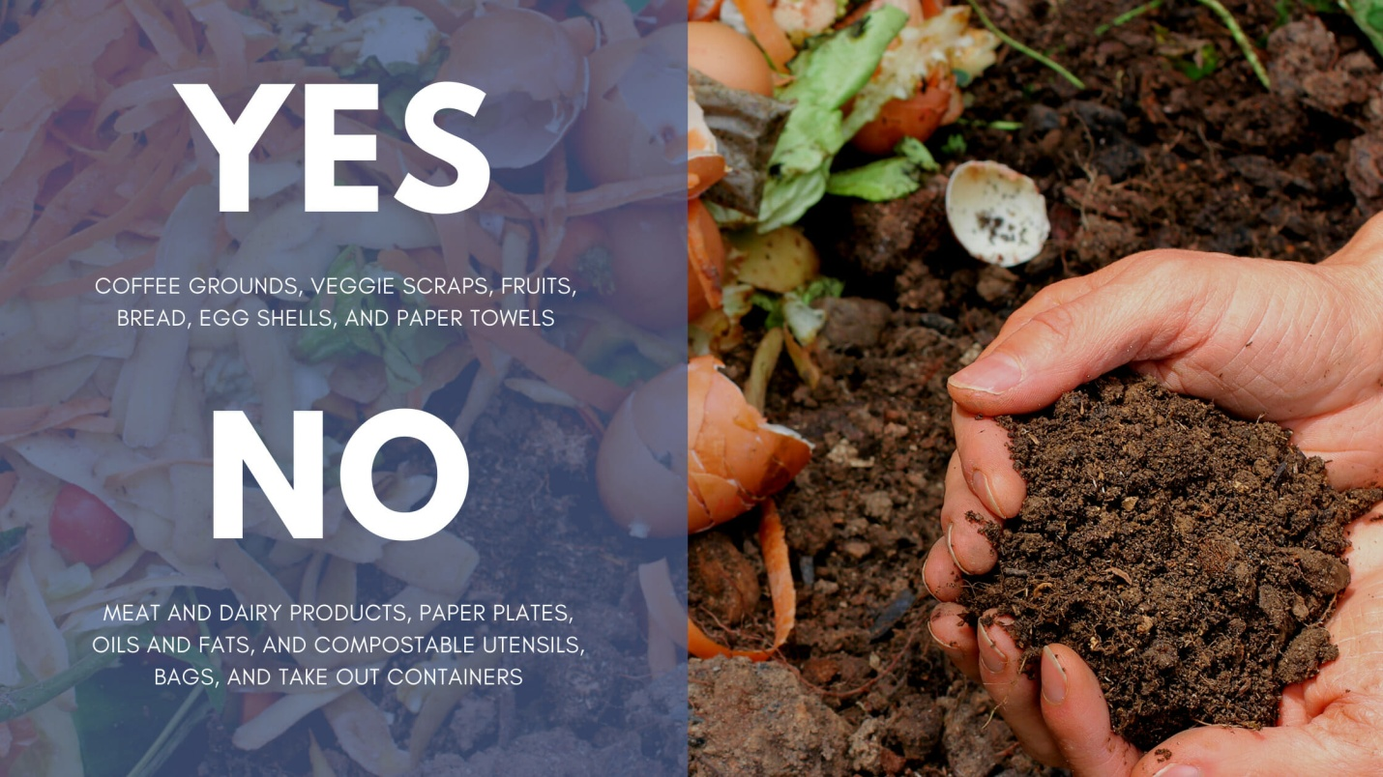
Compost will be available for free to those who want it for their gardens if there is excess; the compost would be offered on a first-come, first-served basis.
If the HCG should receive a company sponsor, Hughes Trash Removal is an ideal candidate: the HCG can request monetary donations toward creating small kitchen compost bins that can be provided to the members of the community to collect their kitchen scraps throughout the week and can be emptied at our location.
Example:
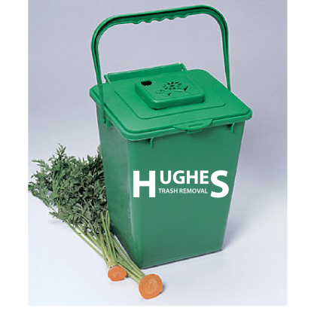
Benefits of Composting
- Enriches soil, helping retain moisture and suppress plant diseases and pests.
- Reduces the need for chemical fertilizers.
- Encourages the production of beneficial bacteria and fungi that break down organic matter to create humus, a rich nutrient-filled material.
- Reduces methane emissions from landfills and lowers your carbon footprint.

Local Plots Co-Op
A small area of the greenhouse has been allocated to provide a number of plots that can be “purchased” through a lottery system and used by individuals, families, or businesses. There will be a time period during which, for a small fee, anyone who wants to own a plot in the greenhouse may “register” and purchase a lottery ticket for a plot. Only a small number are available.
Available plots will be divided in half and split between residents and restaurants. Those who win the lottery will own that plot for one (1) year; they may grow whatever they wish as long as it is approved by the BOD and includes only noninvasive plants.
The revenue earned through the lottery shall be used to better the greenhouse as determined by the BOD.

Community Contributions and Needs
The needs of the greenhouse will change from year to year and from season to season, depending on the influx of donations and what is acquired over time. The HCG’s needs are separated into two categories:
Perennial Needs: Items and services that are needed on an ongoing or repetitive basis.
Annual Needs: Items that are needed only once, or only once for a long-term basis.

Current Perennial Needs
- Soil Donations
- Seeds
- Disposable plant containers
- Propane
- Trash bags and contractor bags
- Towels/rags
- Paper Towels
- Screen
- stakes
- Mixing containers
- Pots
- Seedling flats
- Contractor Buckets
- Bleach Disinfectant
- Mold resistant paint
- Paint brushes
- Paper
- Printing Services
- Plastic tubs
- Hand Sanitizer
- Soap
- Tarp
- String
- As-needed repairs to ventilation, heating, structural, and water system
Current Annual Needs
- Chairs
- Tables
- Carpenter services
- 2x4 Plywood
- Shelving
- Trash cans
- Spray Bottles
- Large Community –grade composting barrels
- Shovels
- Trowels
- Rakes
- Pruning Shears
- Wheel Barrows
- Labels and markers
- Garden Shears
- Fans
- Watering Cans
- Gravel
- Thermometers and humidity gauges
- Hoses and fittings
Due to sanitary reasons and COVID-19, all volunteers must supply their own approved gloves and masks.
Donations and contributions of greenhouse needs will be handled by the BOD. The community can supply these needs in the following ways:
- Monetarily
- In-Person donation of used equipment and/or materials in good, safe condition
- From the Amazon wish list

Marketing
The HCG will have the following, and for the first year will be supplied and maintained by Hampstead Marketing and Design:
- Website
- Facebook
Our goal is to market the Community Garden as a free and open space for visitors, a fun and rewarding place to volunteer, and a service to the community. Interested volunteers will be encouraged to help with marketing efforts.
Events
Once a Fundraising Director is elected, the BOD hopes that events can be held at the greenhouse to raise money. Such events could include:
- Seed Swaps
- Paint Nights
- Auctions

Financials
HCG finances shall be managed by a Treasurer upon election. All monies donated should be kept in a secure account and invested so as to collect interest. All purchases should be logged and retained for at least three (3) years. Purchases should be approved by the President and all major purchases (over $200) should be approved by the BOD.
Should the non-profit perform well and become financially independent, a new budget and plan shall be created by the BOD to allocate funds responsibly. It is the request of the current President that, should there be an excess of funds, the BOD consider creating an agricultural scholarship to be awarded to a high school senior in Carroll County pursuing an agricultural career path.

